Appendix D – Installation / User Guide

1. Getting Started
   1. Online Access

The Intelligent Reasoning System Xsell is currently deployed to Streamlit Sharing and demo files are available for you to experience the system's functionality. The only system requirement is an electronic device with a web browser.

There is no need to download or install the system, simply use your device's browser (Google Chrome is recommended) with an internet connection and open the URL “ **<https://irsgroup3-bykhwbgdczbhvd3zyfezlc.streamlit.app/>** ” to start using the intelligent reasoning system Xsell. You will see the login screen as shown below.

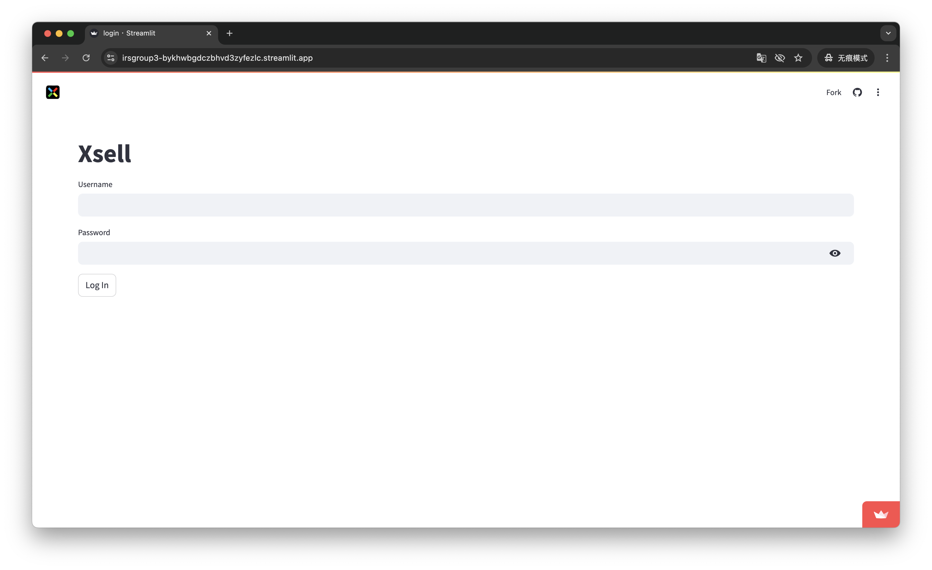

Please note that applications on Streamlit Sharing are usually dormant after several hours of no access. The application will automatically wake up when someone visits, but the first visit may be slightly delayed. If you see the screen as shown, please be patient and the app will wake up again. You can also try refreshing or reopening the interface. If it still doesn't work after a while, please contact a technician, thank you for your understanding and cooperation.

1.2. Off-line Access

1.2.1. Installation

System Requirements

This system has no system limitations and supports Windows, macOS and Linux systems.

Configuring Your Runtime Environment

To avoid conflicting versions of dependent packages in your original environment, it is recommended that you create a new Python environment. Python version 3.11 is recommended.

Installing Required Python Project Dependencies

You can quickly download all the dependency packages using the following command line in the terminal ‘ **pip install -r requirements.txt** ’ .

The required dependencies are as follows (all of the following packages are current as of October 20, 2024).

streamlit

plotly

pandas

openpyxl

matplotlib

joblib

scikit-learn

numpy

deap

Downloading the system code

Clone or download project source code from GitHub repository using the URL“ **<https://github.com/JIAtype/IRS_Group3.git>** ”.

1.2.2. Running the system

Run the app.py file

In the folder where you saved the run file, open a terminal and use the command line ‘ **streamlit run app.py** ’. After running successfully, a URL link will be displayed as shown in the figure.

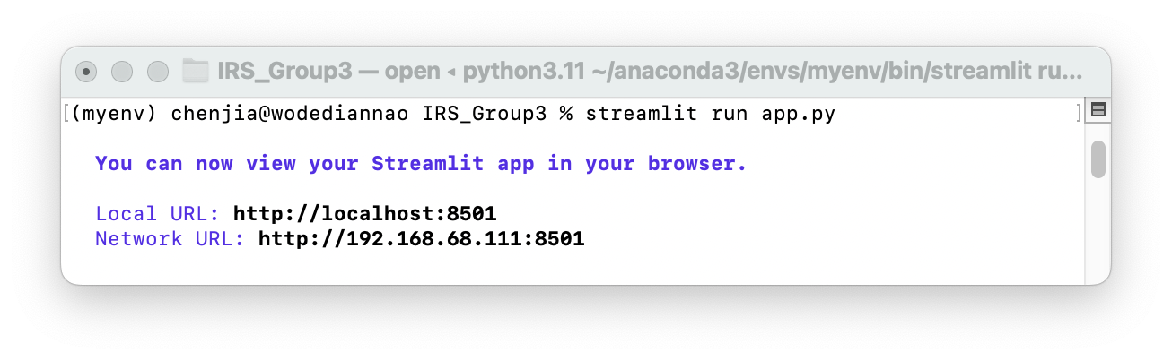

Open the URL link using a browser (Google Chrome is recommended) to see the login screen as shown in the figure.

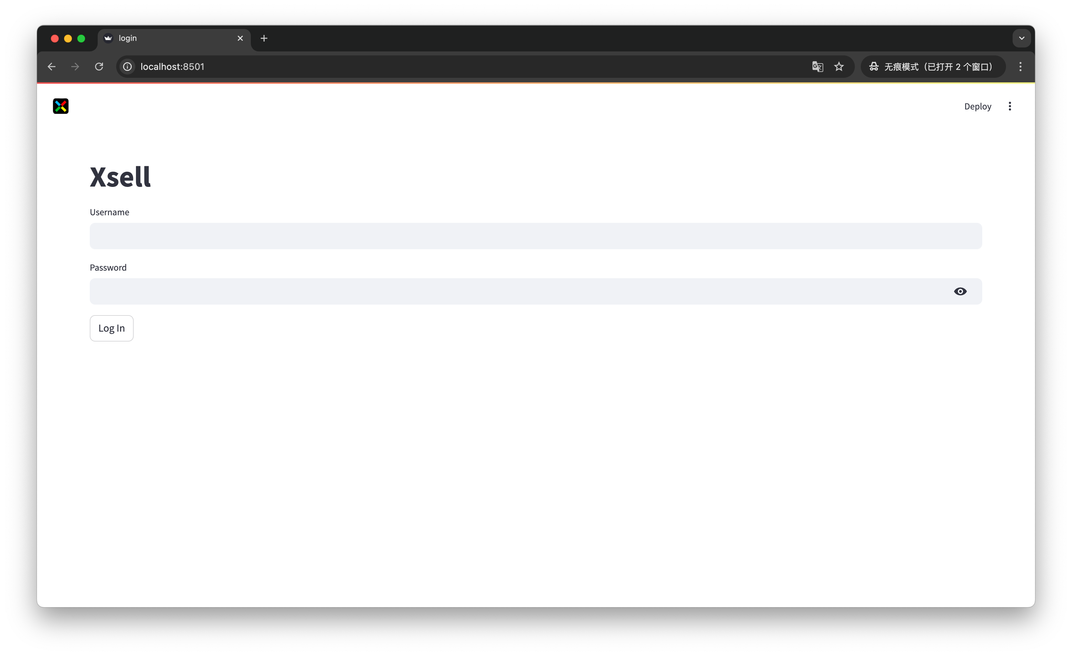

2.User Guide

2.1. Login and Logout

For different identity users, different interfaces and functions will be displayed.

As a department store administrator, you can use the user name “**admin**”, password “**123456**” to log in the system, enter the home page, as shown in the figure.

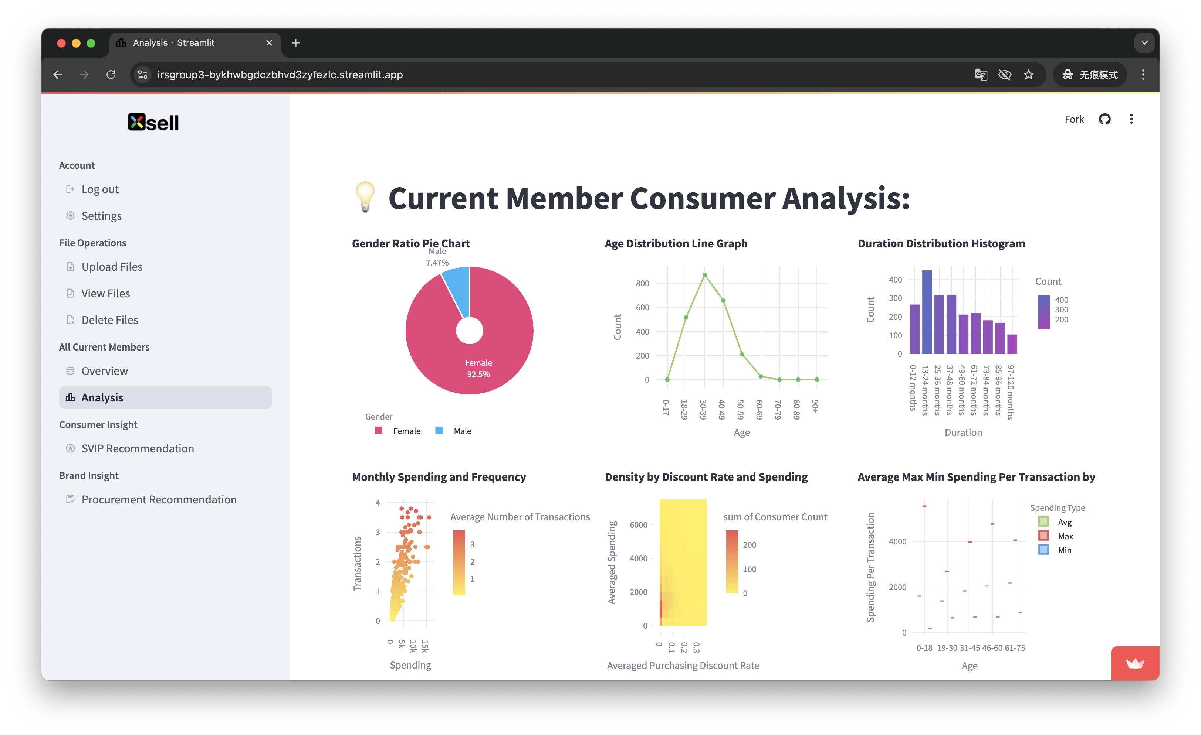

As a department store salesperson, you can log in to the system using the username “clerk” and password “123456” to enter the home page, as shown in the figure.

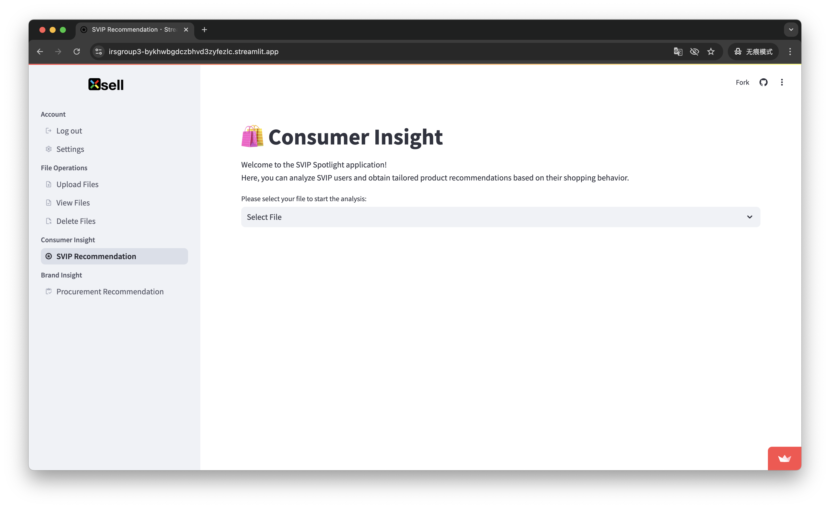

Once you have successfully logged in, you can see the “Log Out” option in the Account section of the sidebar, click on it to log out.

2.2. File Operations

In this section, you can perform all file-related operations.

2.2.1. Uploading Files

All functions require data support, so before using the system functions, please perform the file upload operation first. If there are no files in the system, a reminder message will be displayed as shown below. Note that the first time you run the system, all the necessary demo files are already included for you to experience the system functions.

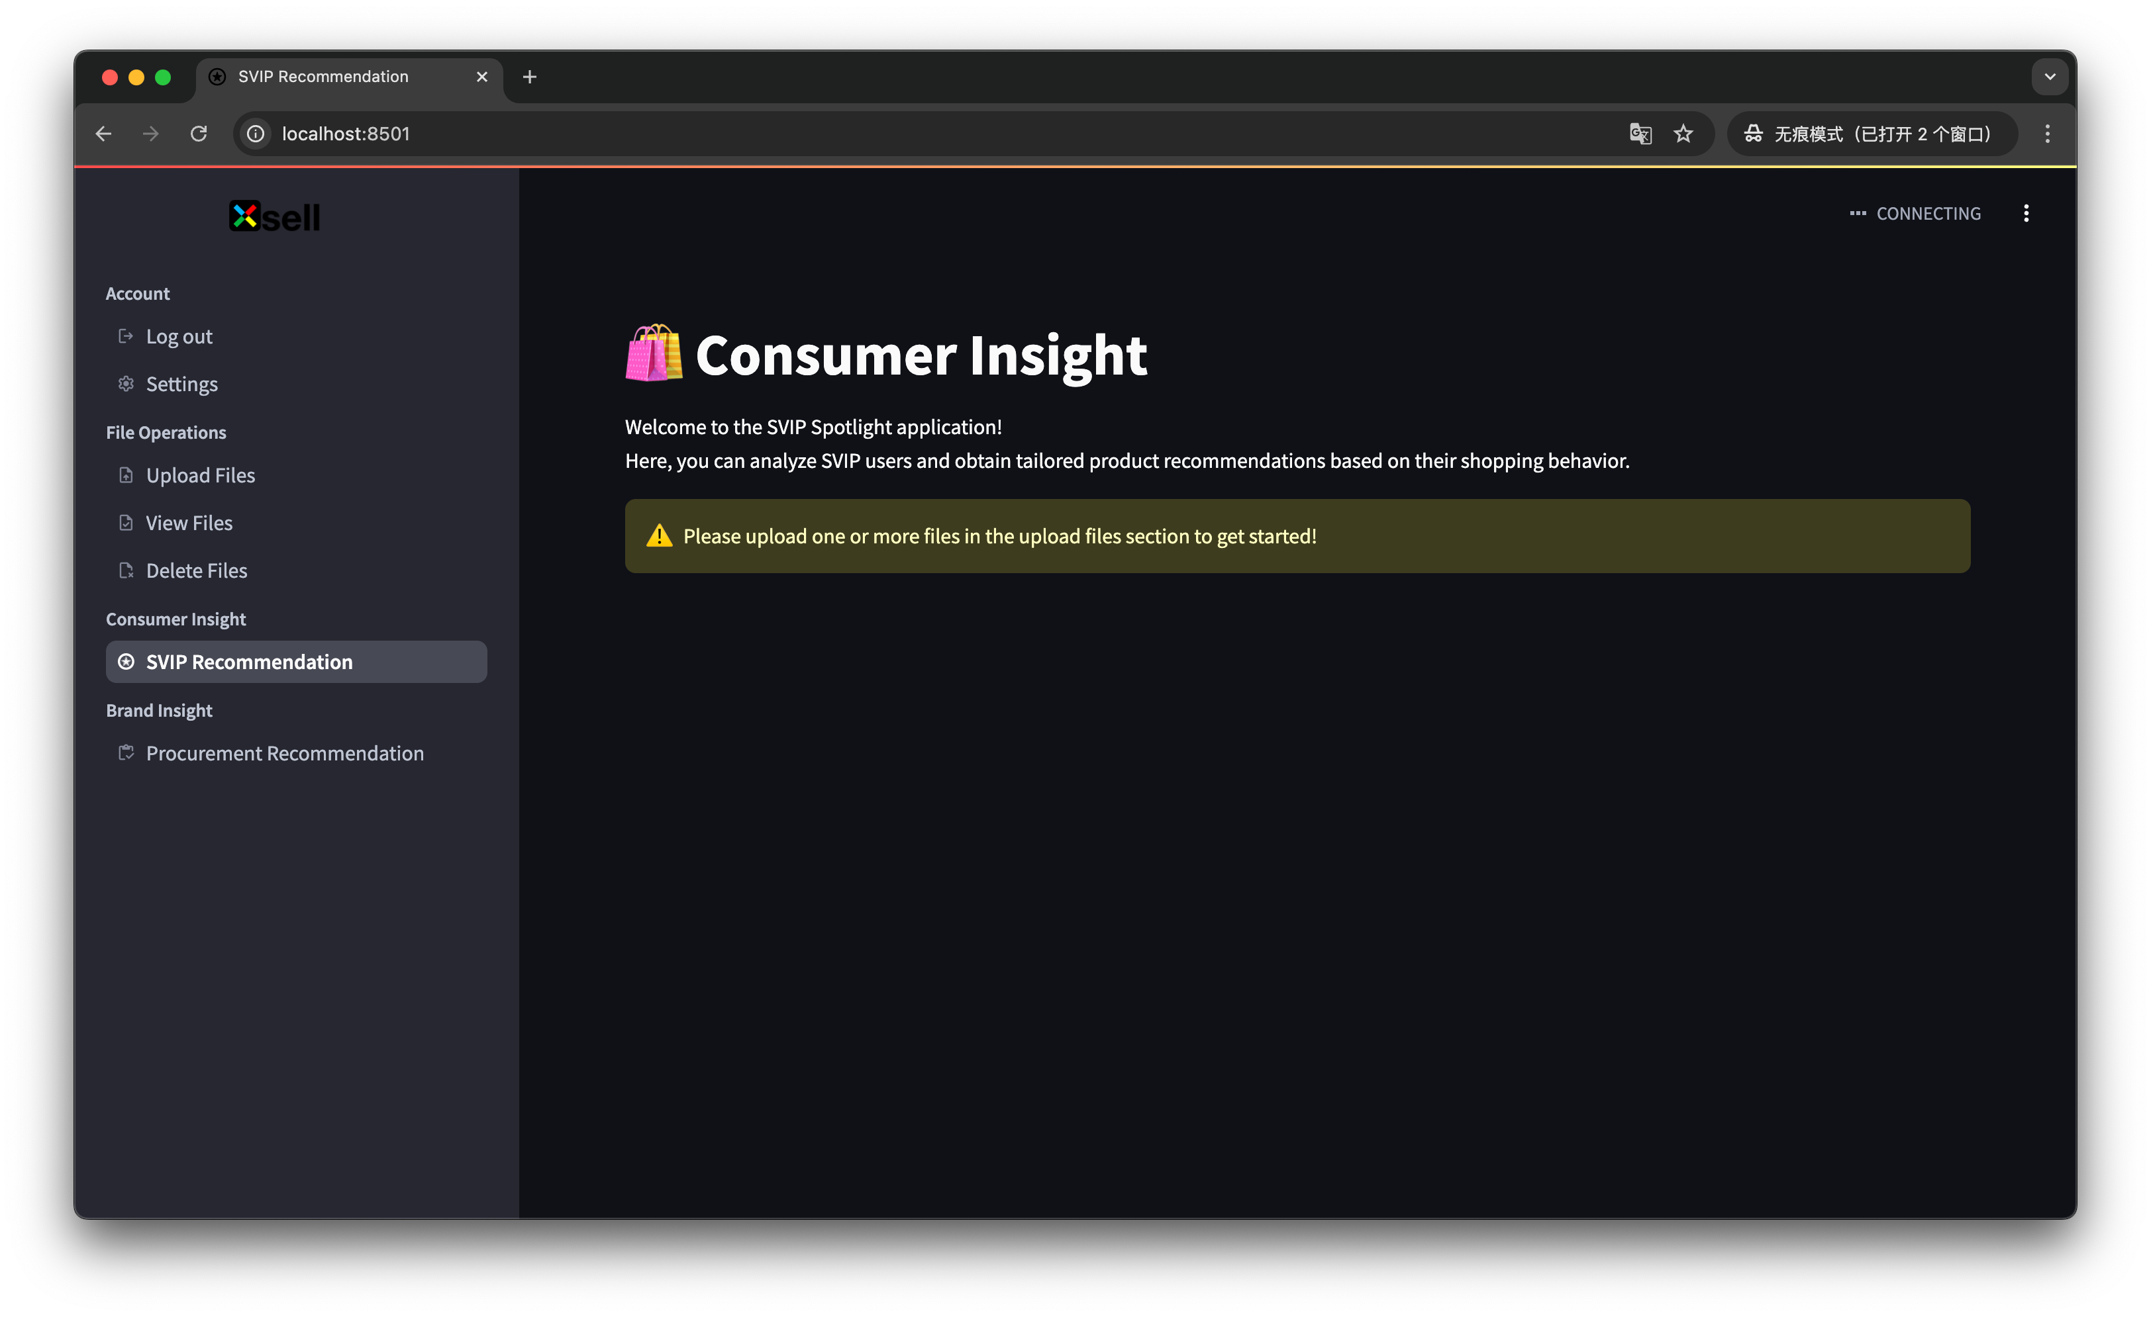

In the File Operations section of the sidebar, check the Upload Files page. Click the “Browse files” button to view your local files and select one or more files you want to upload. Note that only .xlsx or .csv files can be uploaded. A prompt will be displayed when the upload is successful, as shown in the figure.

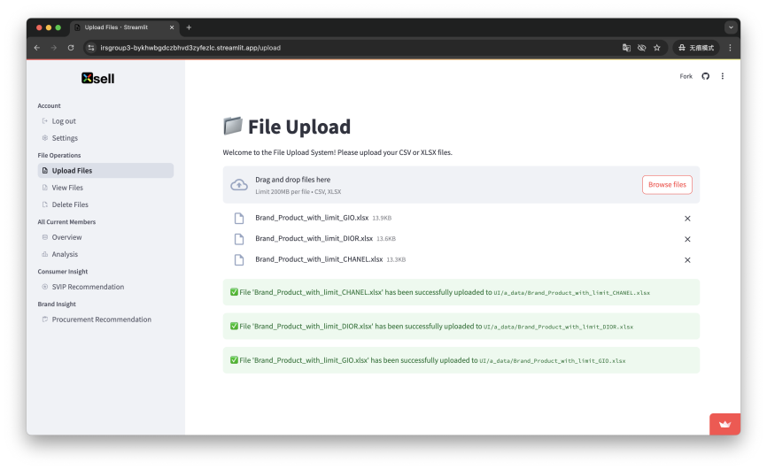

2.2.2. View Files

In the File Operations section of the sidebar, check the View Files page. Click the drop-down box to see all the files in the system. Select the file you want to view to display the raw data from the file you selected, as shown in the figure.

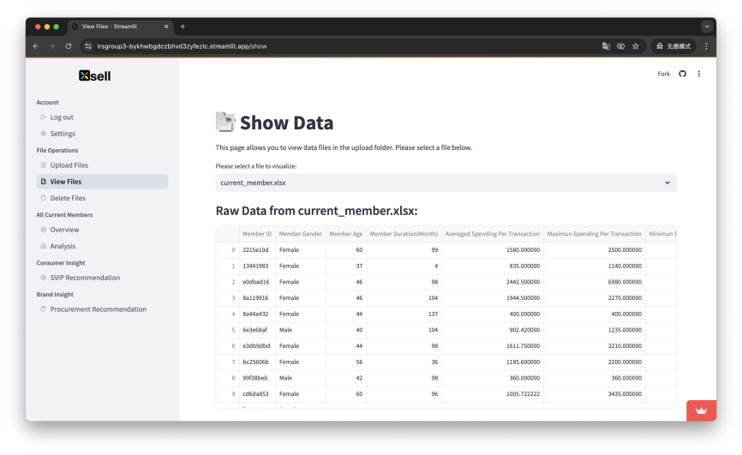

2.2.3. Delete Files

In the File Operations section of the sidebar, check the Delete Files page. Click the drop-down box to see all the files in the system, select the file you want to delete, and click the “Confirm Delete” button to delete the file. A prompt will be displayed after successful deletion, as shown in the figure.

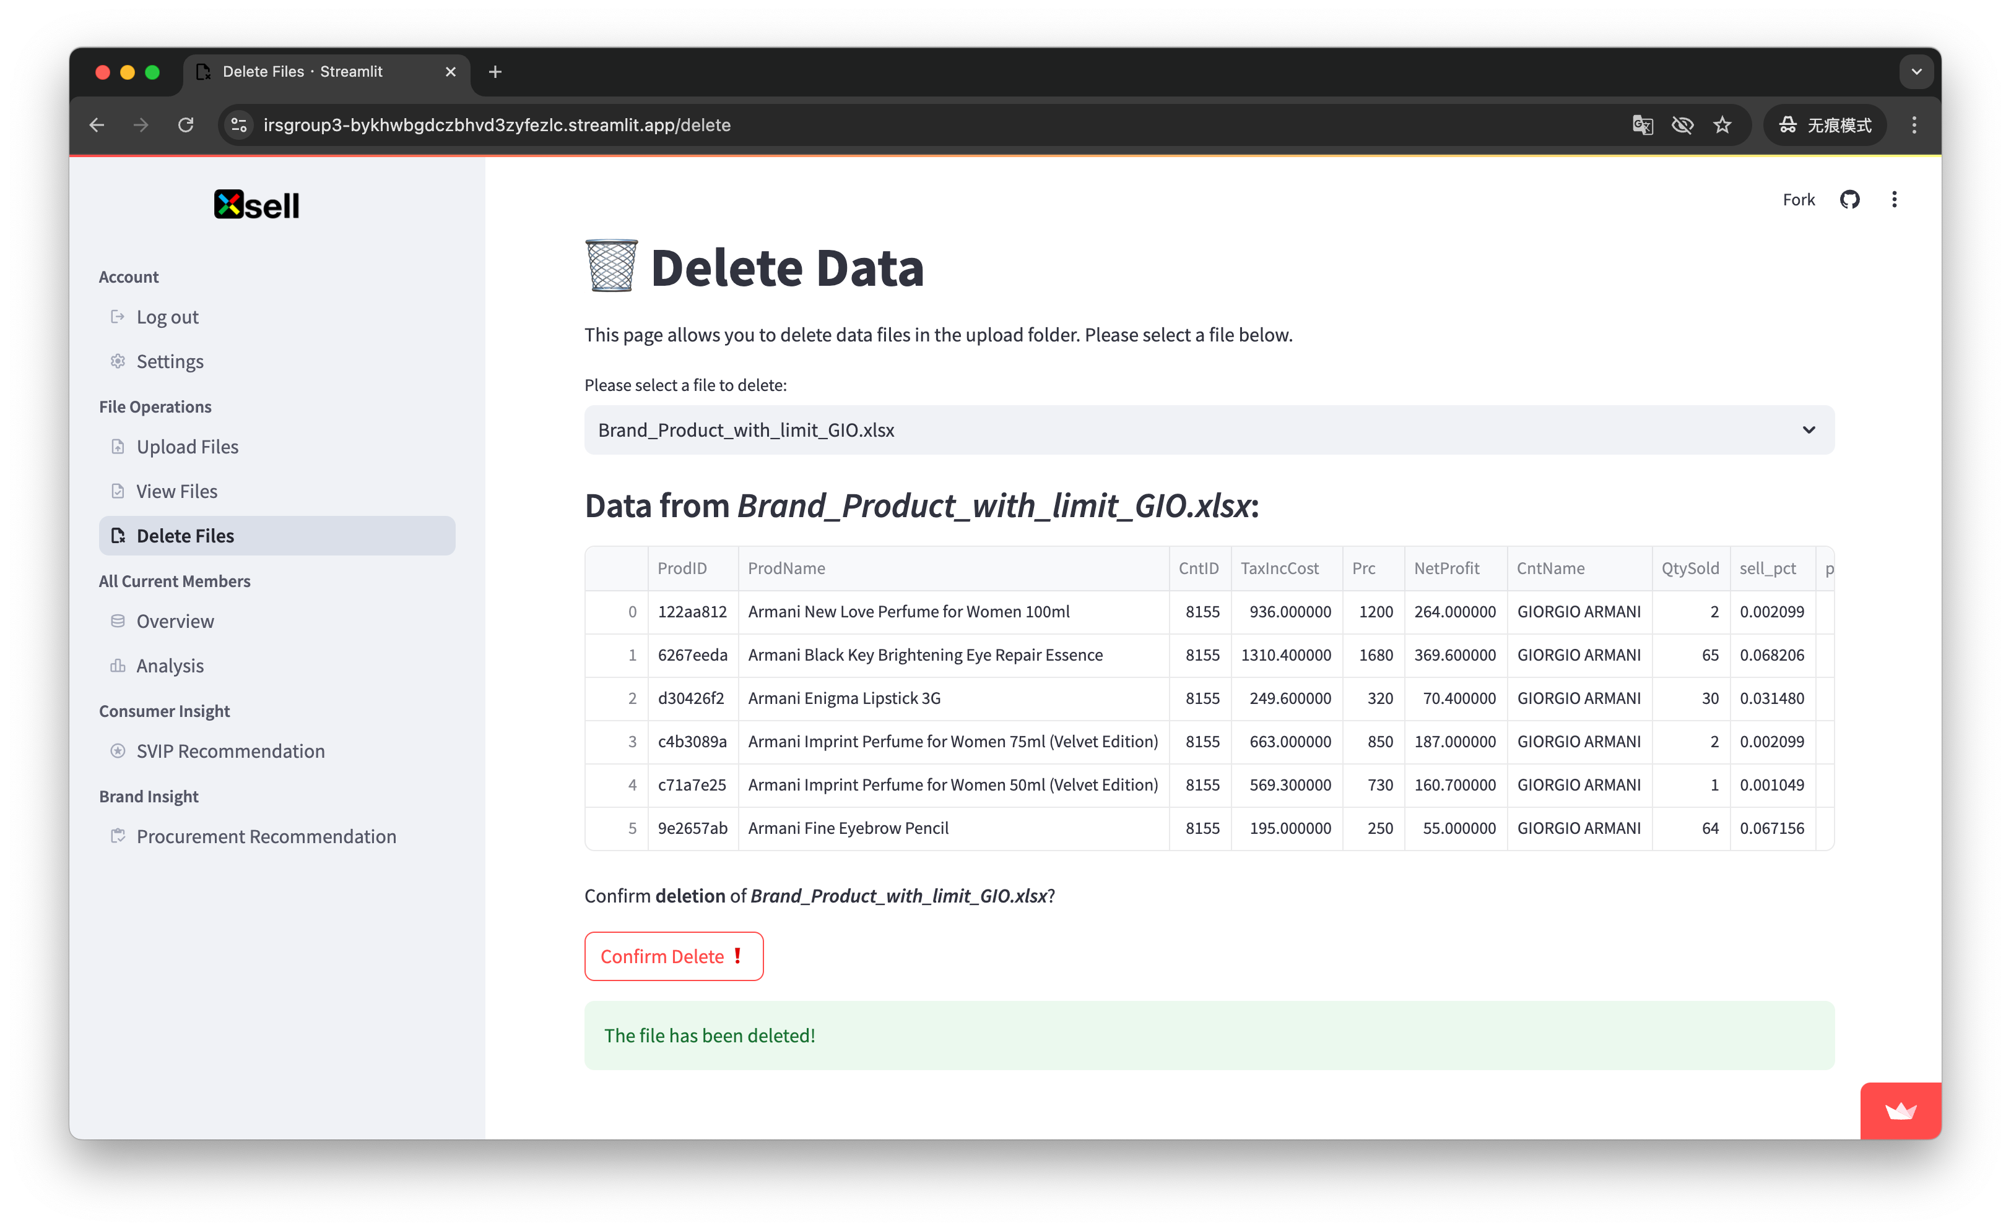

2.3. All Current Members

In this module, you can view information about all current members of the department store and their data visualization charts. Note that this part of the functionality is only available to department store administrators, salespersons are not authorized to access it.

2.3.1. Current Member Consumer Data Preview

In the All Current Members section of the sidebar, select Overview, as shown in the figure, to view the raw information of all current members from the current_member.xlsx file. This information will be used to generate all charts on the Analytics page, so it will be checked to see if it contains the basic information “Member ID”, “Member Gender”, “Member Age ”, “Member Duration (Month)”. If the information is complete, a normal reminder will be displayed.

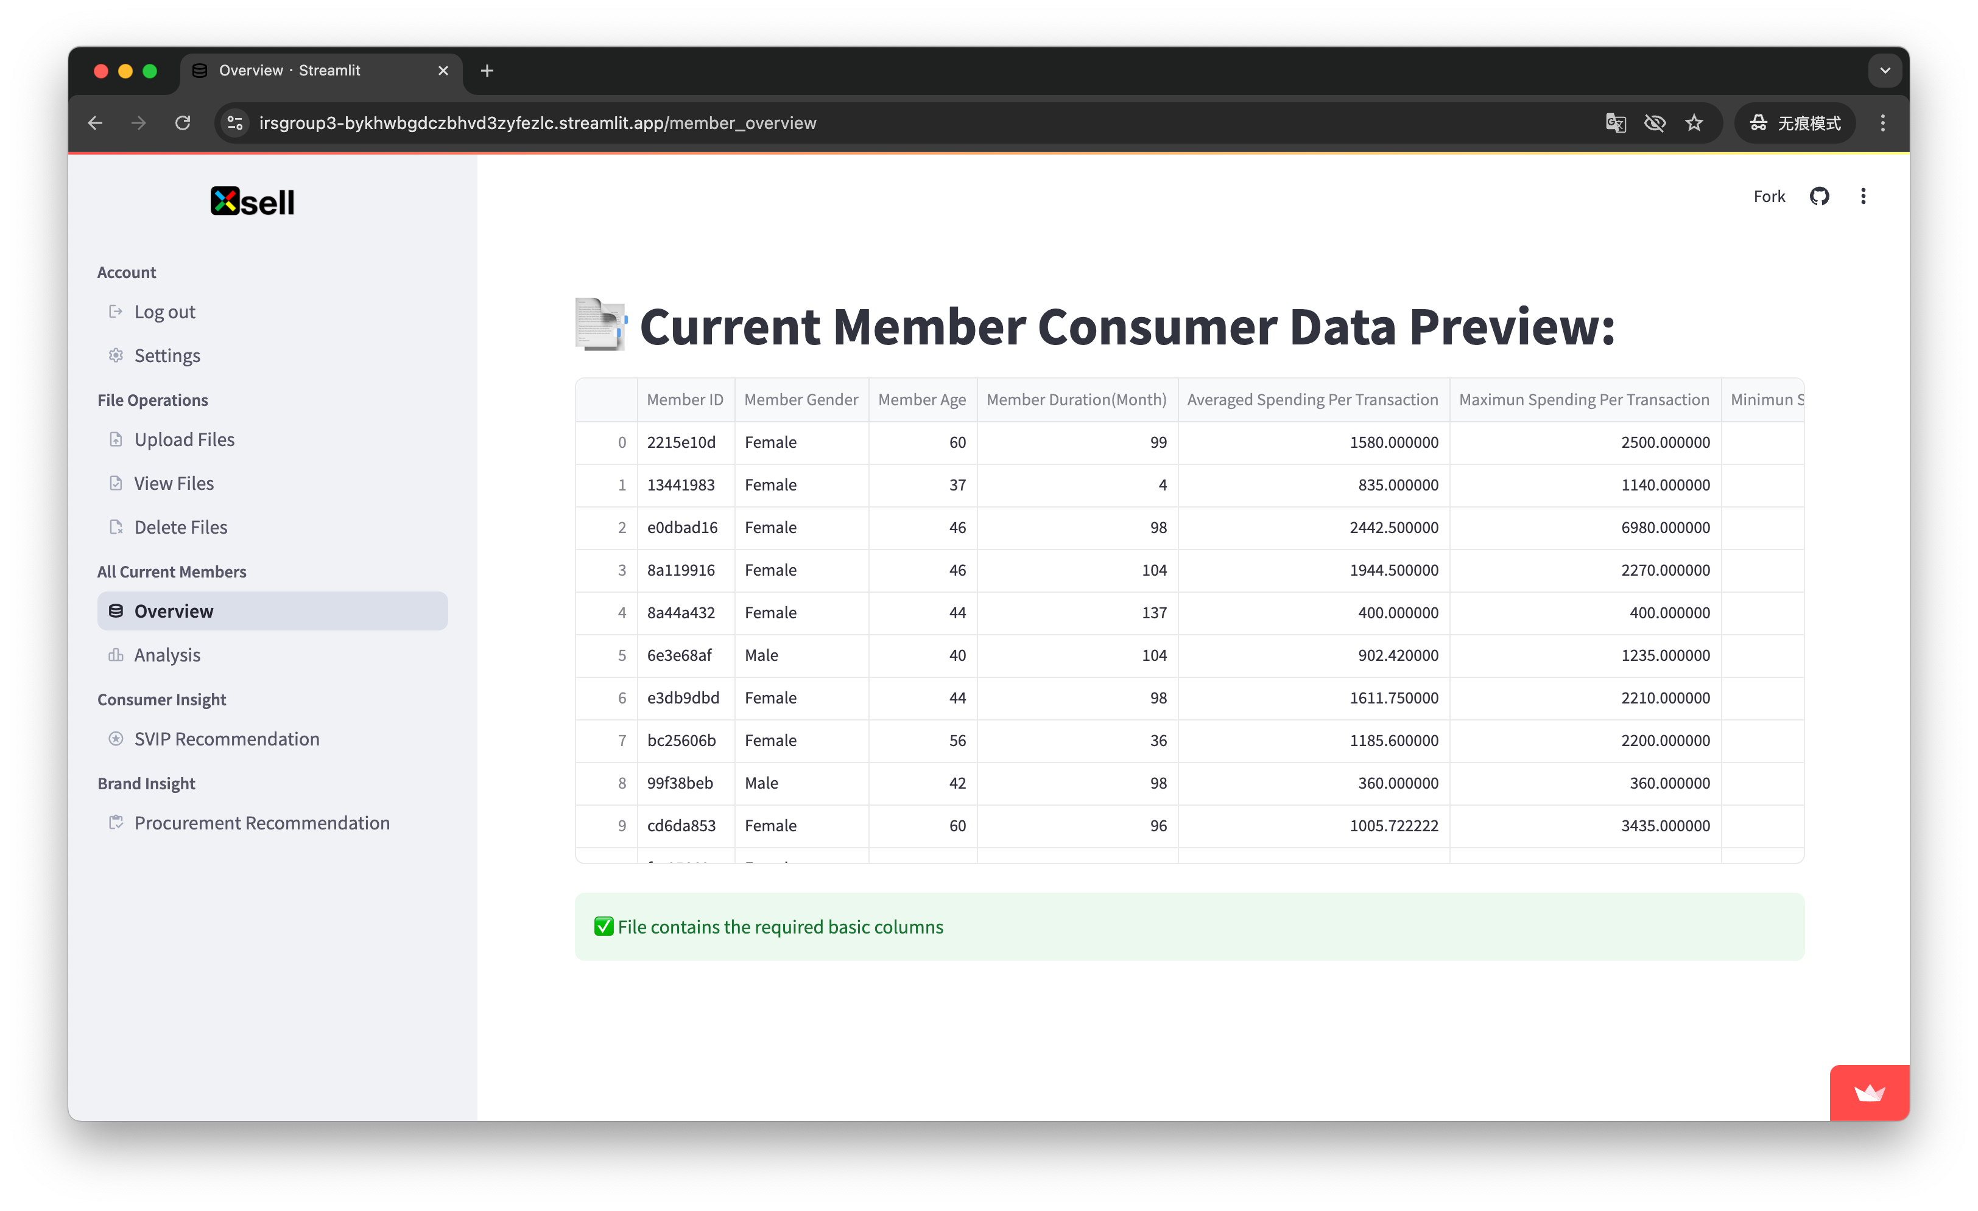

2.3.2. Current Member Consumer Analysis

In the All Current Members section of the sidebar, select Analysis. as shown in the figure, in this section, you can generate a chart to analyze all the existing member information. Mouse over the top right corner of a chart to save the image, zoom in, zoom out, full screen display and so on.

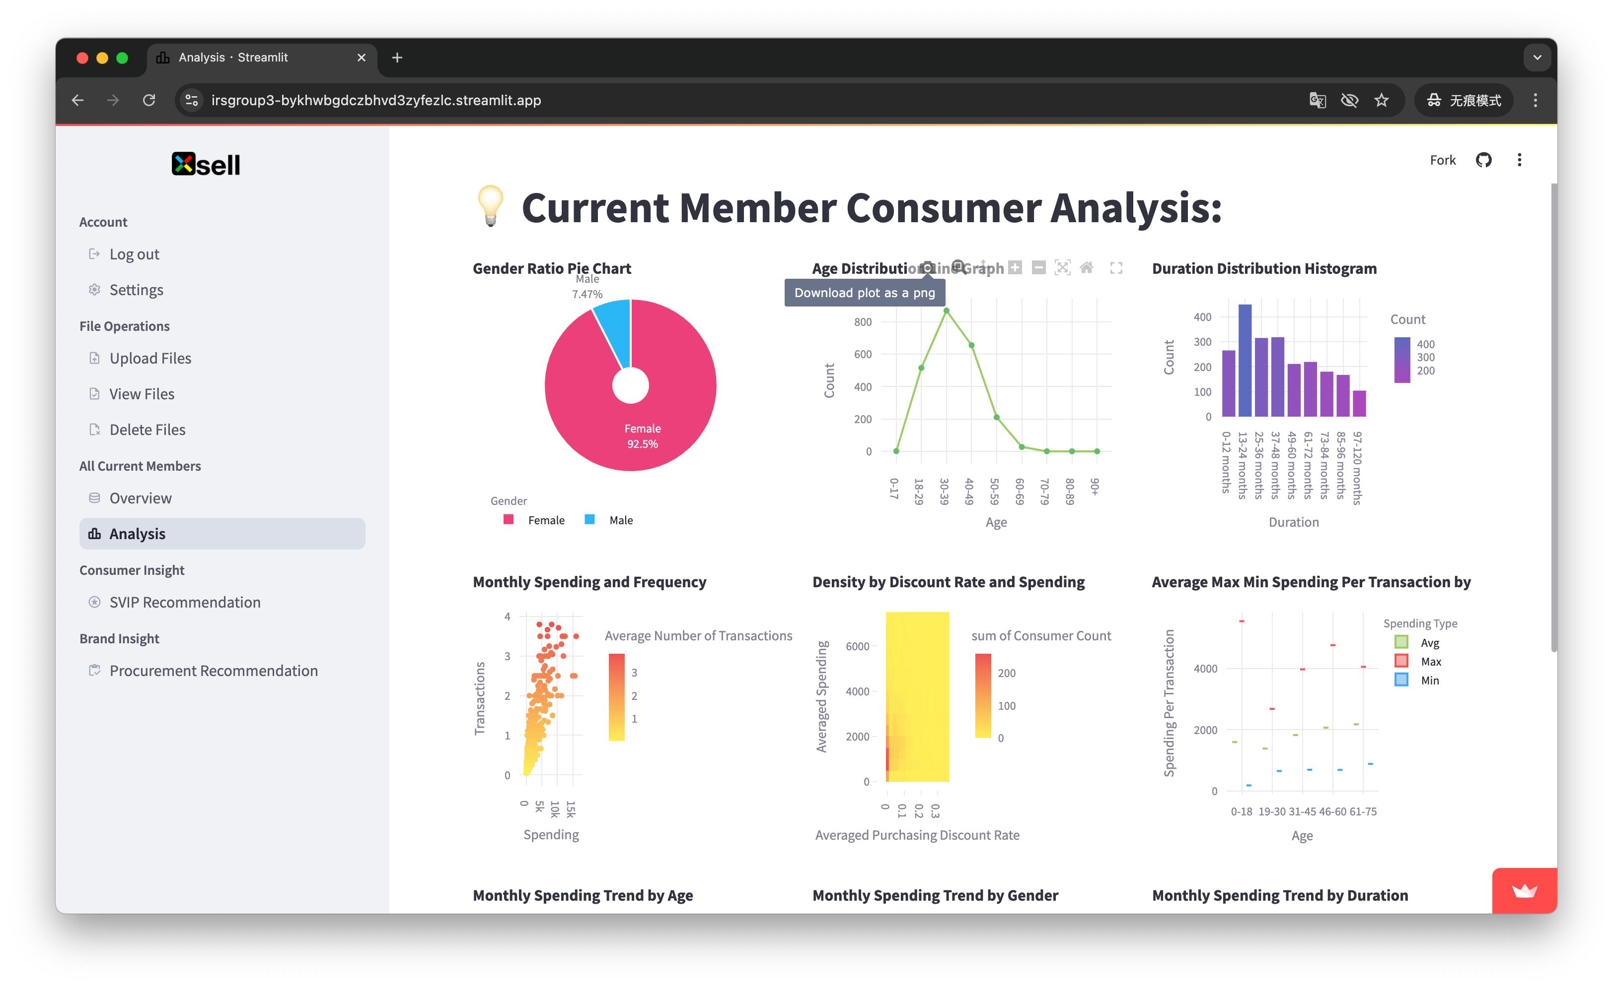

Note that all charts generated by the system are interactive. For example, clicking on the Female label in the pie chart will hide the data for Female and only show the data for Male. As shown in the figure, hovering over the chart will display the details of that section. You can also zoom in on a portion of the chart by holding down the left mouse button and selecting the portion with a rectangular box.

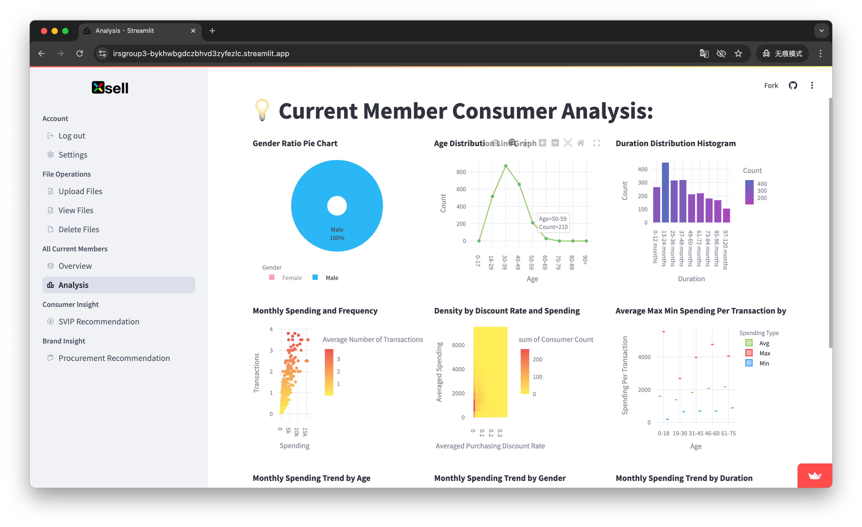

2.4 Consumer Insight

In this module, you can analyze the selected files to determine if the customers are the most valuable group for marketing and provide them with personalized product recommendations. In the Consumer Insight section of the sidebar, select SVIP Recommendation, click on the drop-down box to see all the files in the current system, and select the file you want to analyze. Click the “Analyze” button to view the analysis results, as shown in the figure.

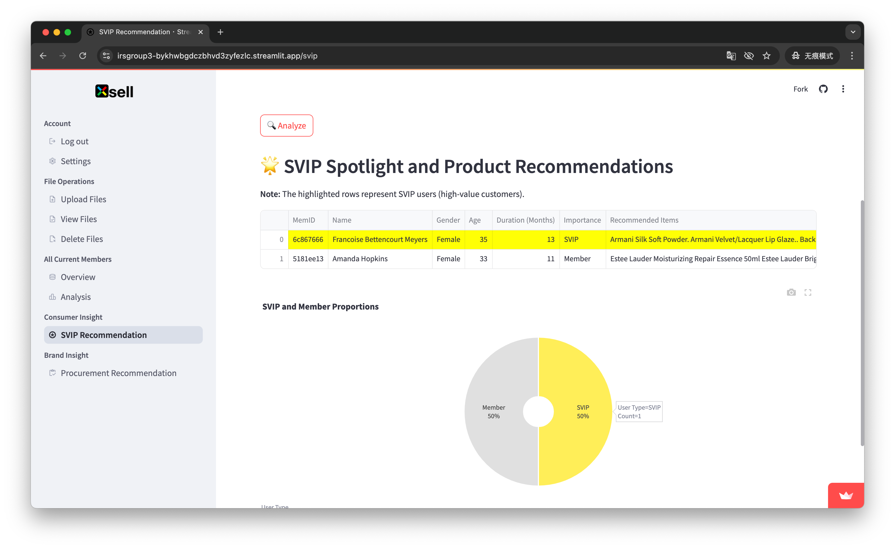

2.5 Brand Insight

In this module, you can analyze the selected files to determine the recommended quantity of goods to be purchased in order to achieve the best yield within the budget constraints. In the Brand Insight section of the sidebar, select Procurement Recommendation. click on the drop down box to see all the documents currently in the system and select the document you wish to analyze. Enter the budget amount, if not, the system will use the default amount of 100000. click the “Analyze” button, you can view the analysis results, as shown in the figure. Please note that this part of the algorithm is more complex, it may take a long time, please wait patiently for the results.

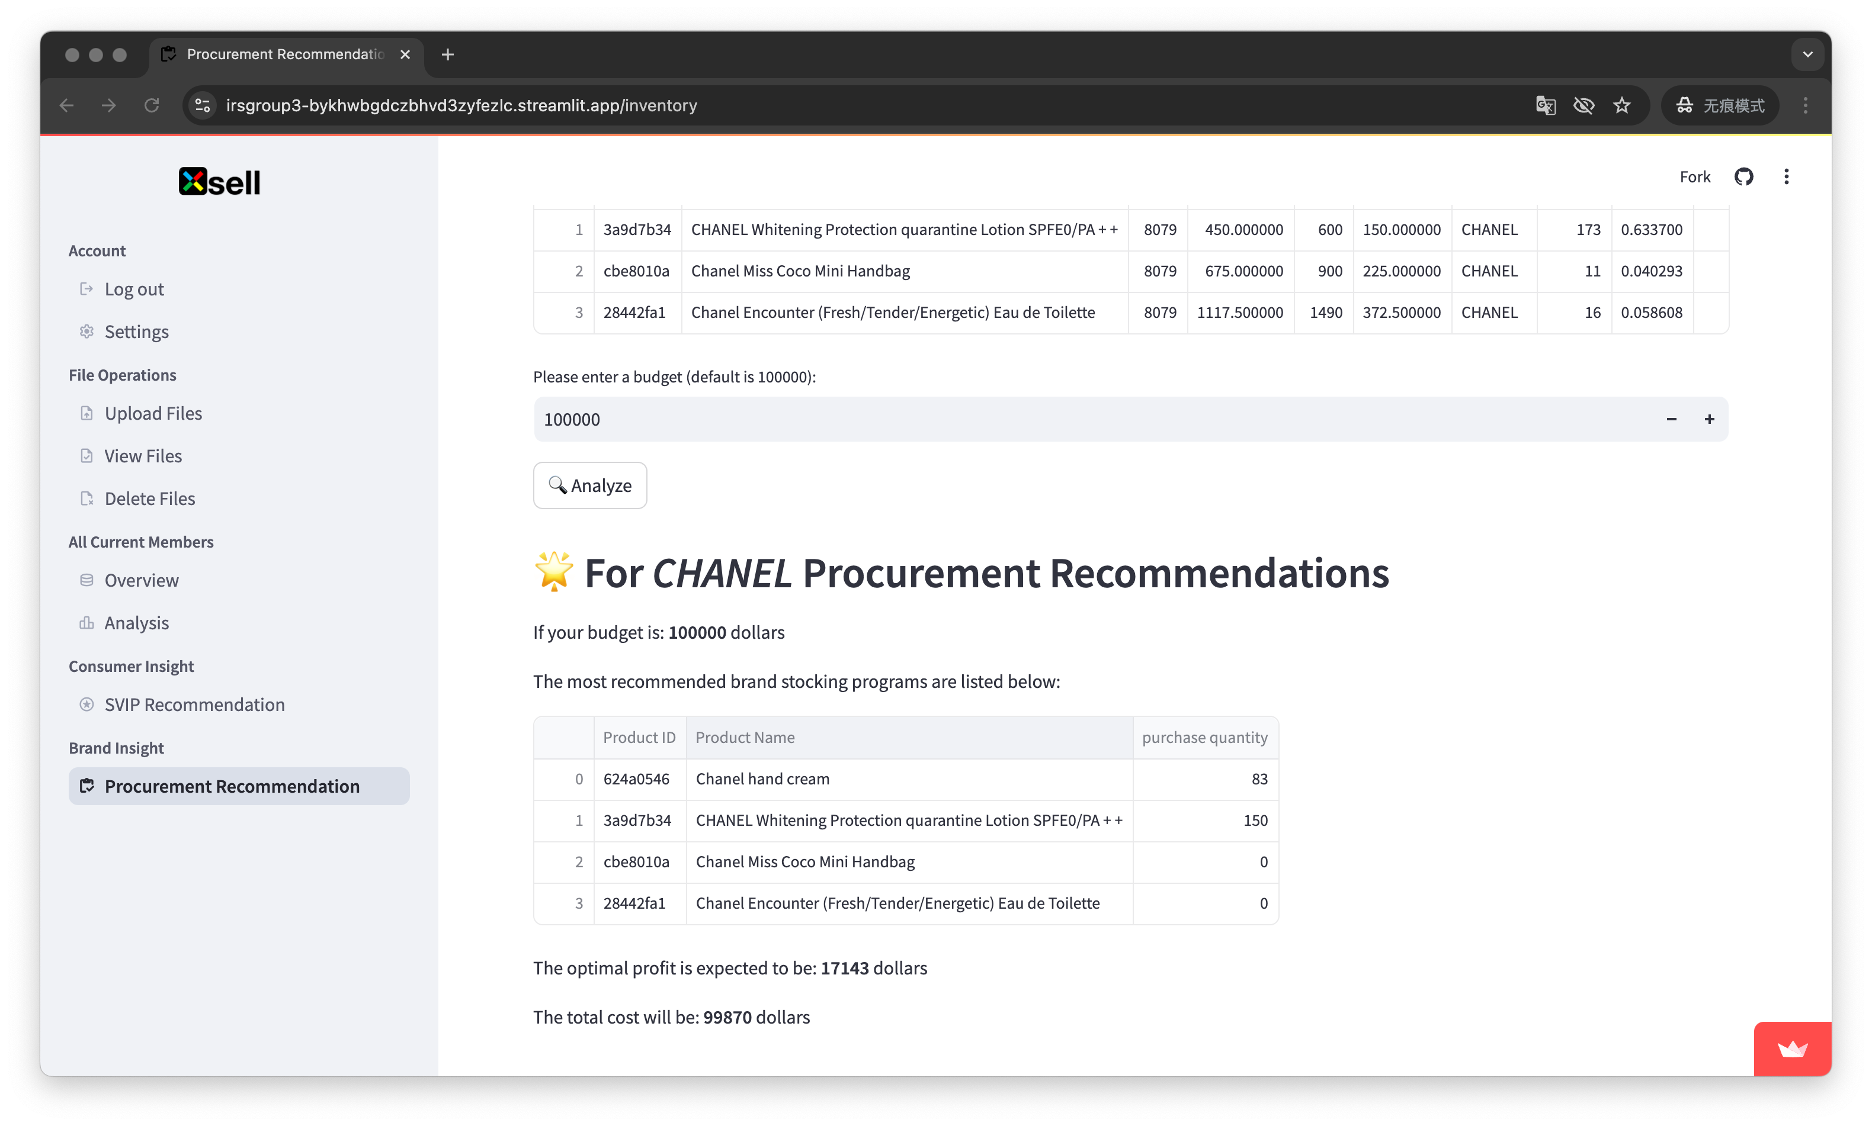

3. Frequently Questions

All the functions of this system are based on the data extracted from the uploaded files, so the file format and content are very critical. You may encounter some problems that the functions cannot be used due to the incorrect format of the uploaded files. Please follow the system prompts to re-upload the file with correct format, naming and header. Below are some common situations for your reference.

Scenario 1: Current_member.xlsx is not uploaded, the All Current Members module of the system can not run normally, and there will be a reminder as shown in the figure in both Overview and Analysis. Please re-select or upload the appropriate file.

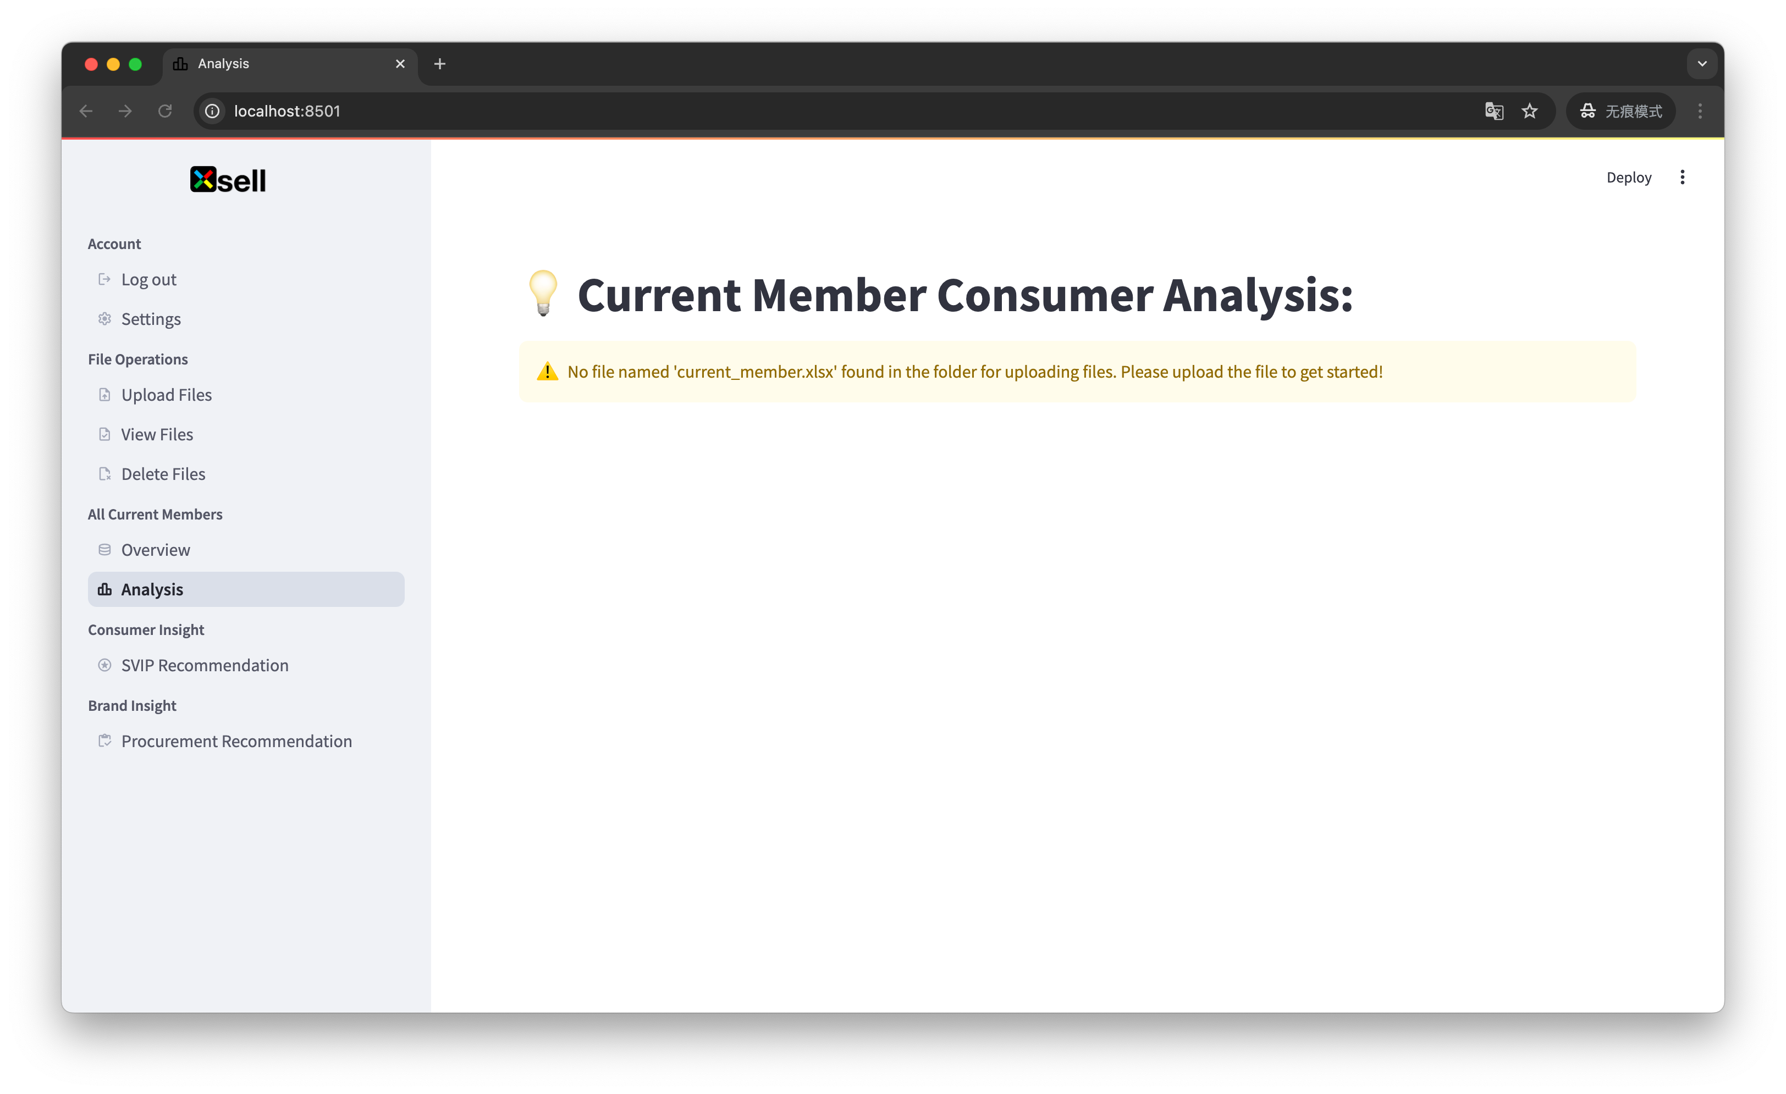

Scenario 2: current_member.xlsx is missing required base information The Overview screen displays the information but alerts you that the required base information columns are missing, as shown in the figure.The Analysis screen will not generate any charts and alerts you that the required base information is missing. Please reselect or upload the appropriate file.

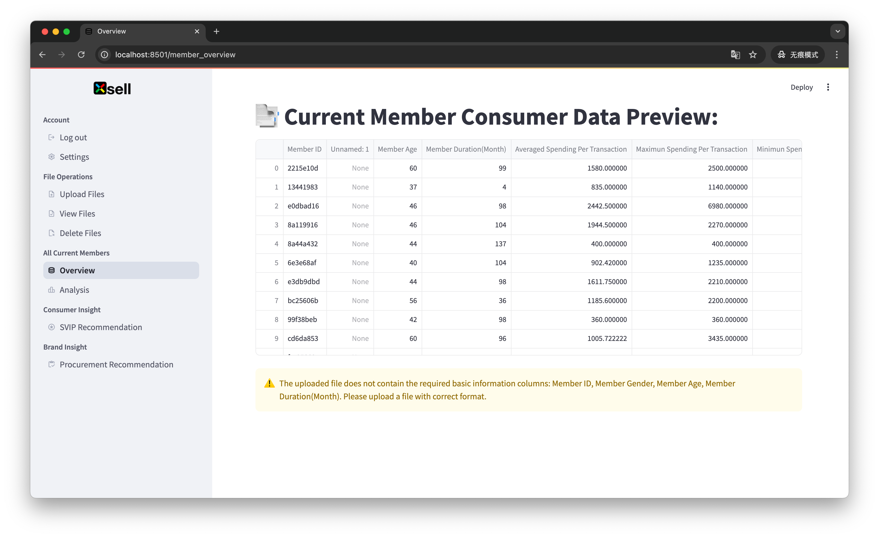

Scenario 3: some information is missing from current_member.xlsx The Analysis interface is unable to generate charts related to the missing information and will alert you to the missing information as shown. Please re-select or upload the appropriate file.

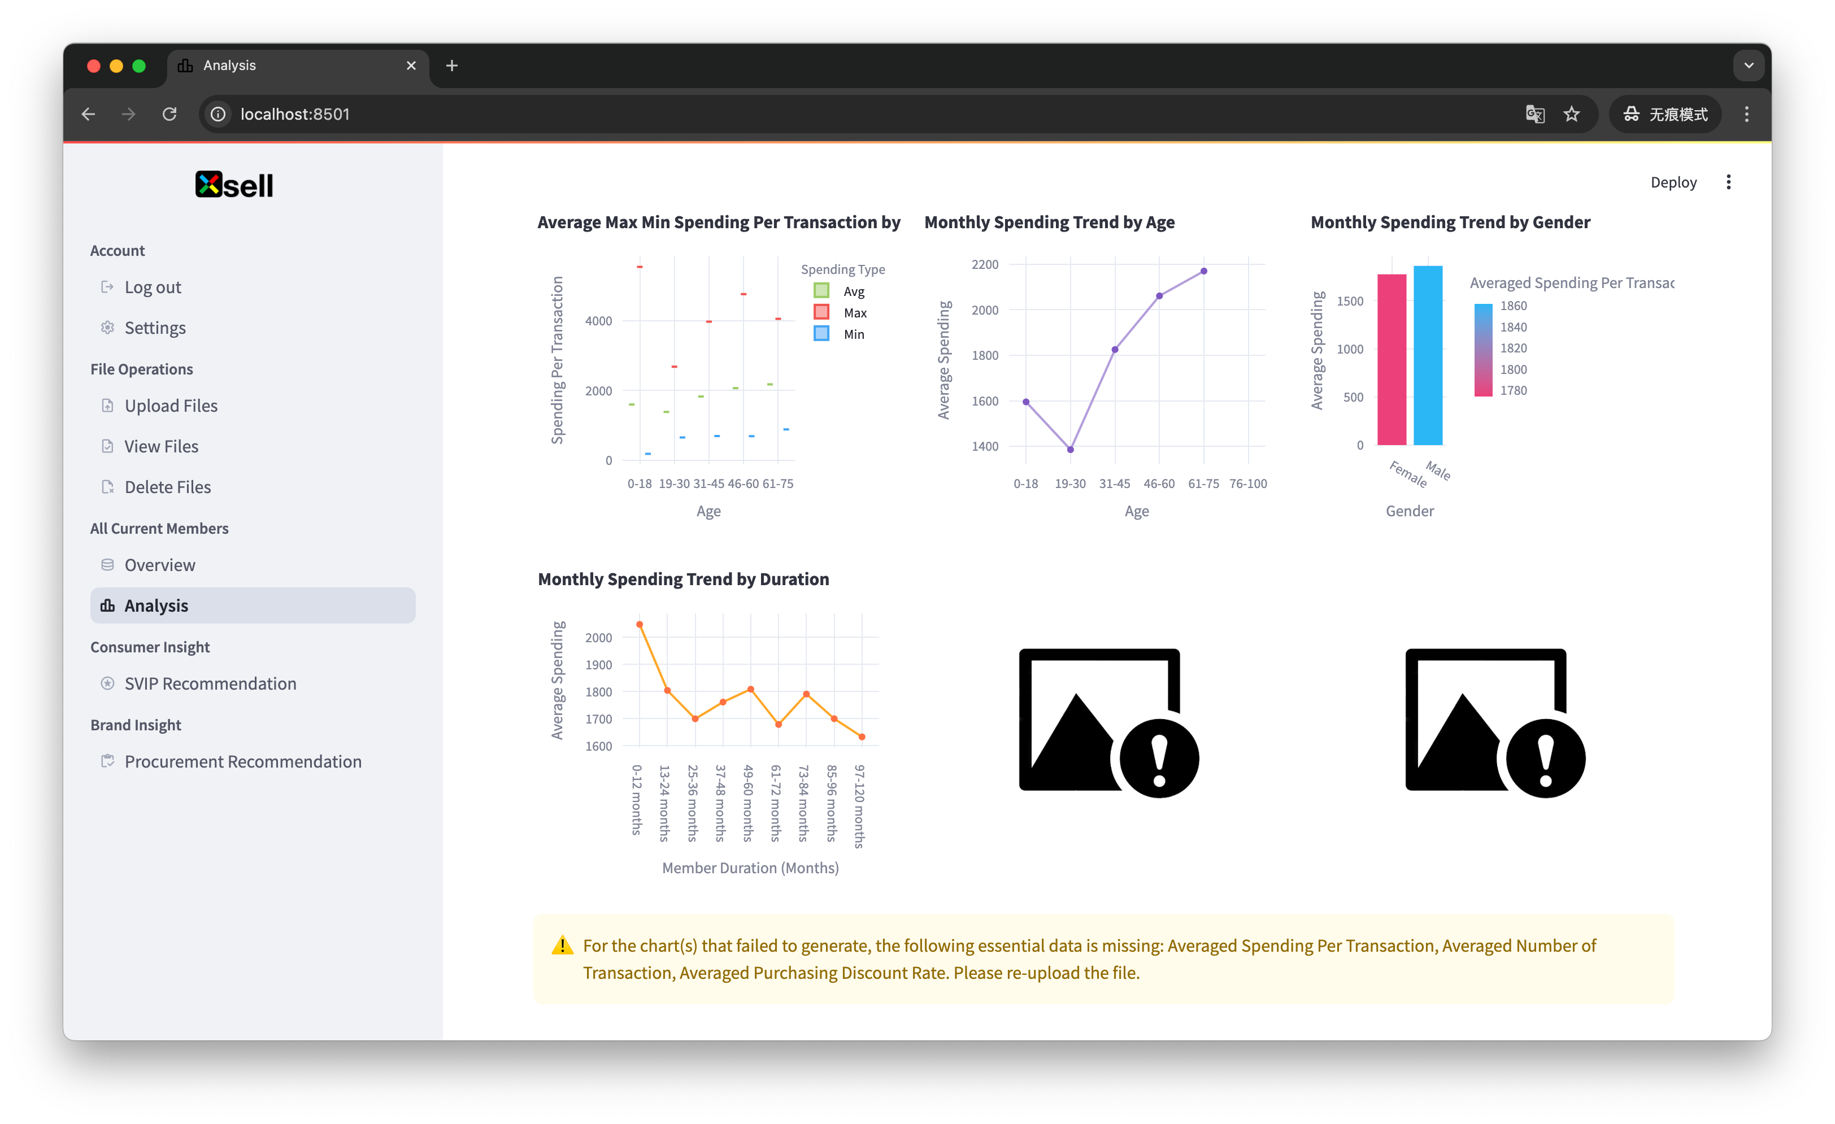

Scenario 4: The file selected in the SVIP Recommendation screen is missing required information. As shown in the figure, the system will display the data you have selected, but will not display the “Analyze” button, which will remind you that the necessary basic information columns are missing. Please re-select or upload the appropriate file.

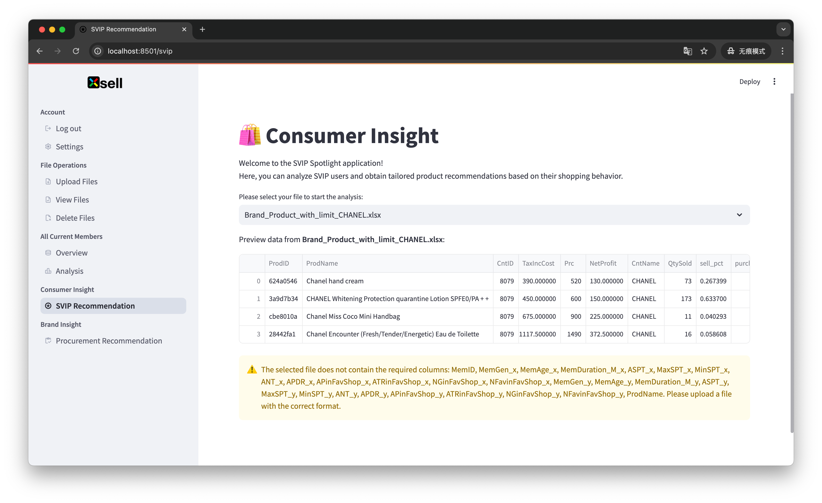

Scenario 5: The file selected in the Procurement Recommendation screen is missing the required information. As shown in the figure, the system also displays the data you have selected, but does not show the “Analyze” button and prompts you that the necessary basic information columns are missing. Please re-select or upload the appropriate file.

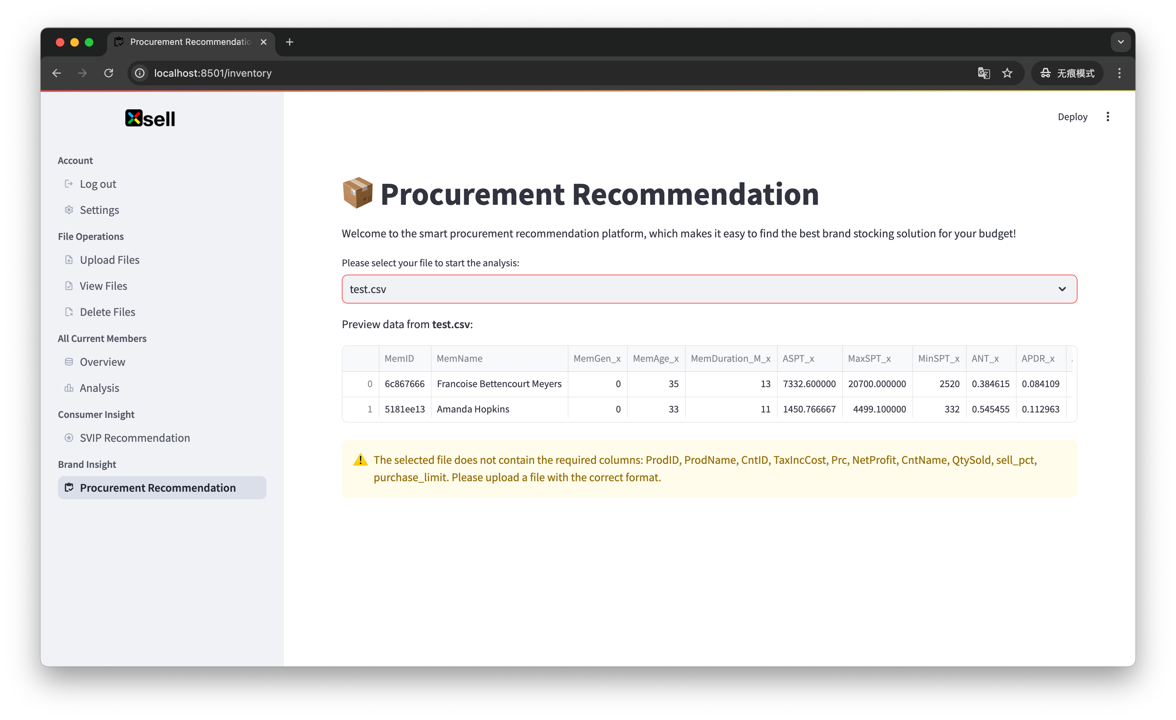

Scenario 6: Under abnormal circumstances, if there are other types of data in the system that were not uploaded by the user, you will not be able to view, manipulate, or utilize the data within the system.

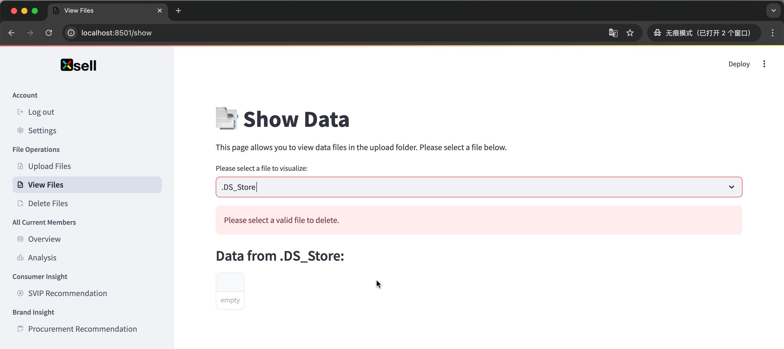

4. Technical Support

If you encounter any other technical problems, please send an email to 1123@com. A technician will review and address your problem.

Thank you for your use.